Kevin Abrahams

CMSC335 Project 2

2/9/21

**User’s Guide (How Start the Program)**

To run this program, the user should first navigate to the directory of the project which is located in the folder called CMSC 335 Project 2. The user can do so by navigating to this folder via the change directory command called “cd” in the command line.

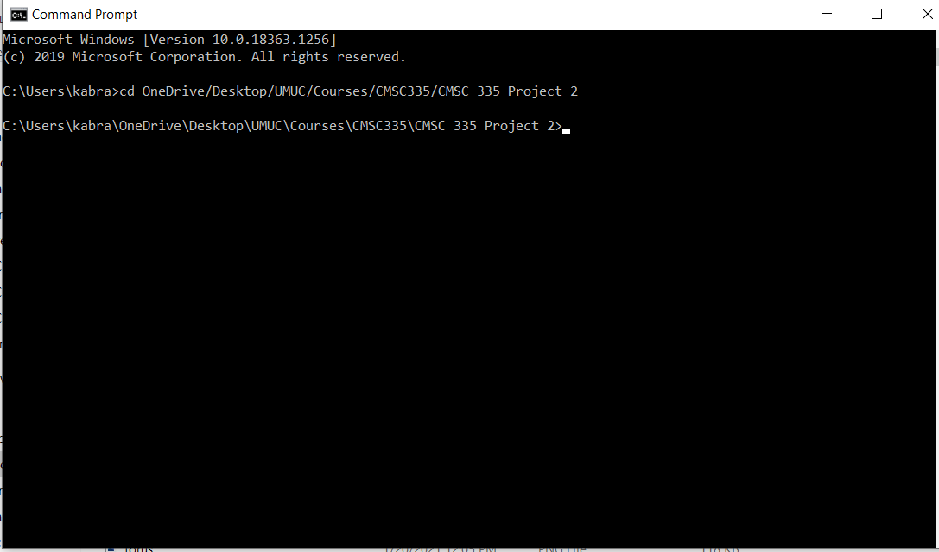

After navigating to the current directory of the folder containing the Java code files, the next step is to compile each of these files using the javac *.java command. Then, run the program by running the file called ShapeTest which contains the main method through the command java ShapeTest in the command line.

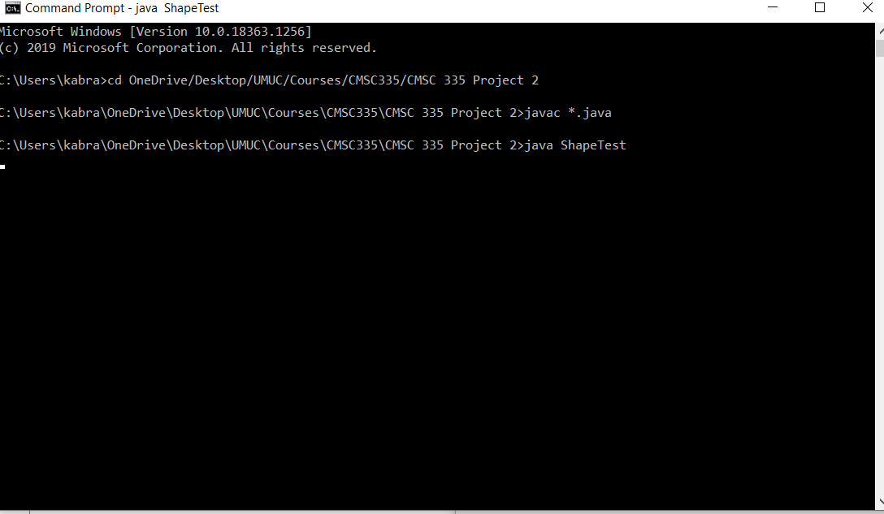

This shall cause the subsequent GUI window to appear, indicating the program has successfully launched. The user may not begin entering and selecting shapes.

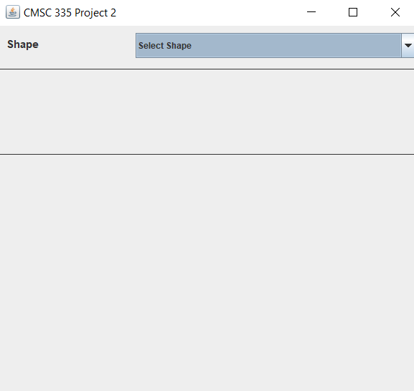

**Test Cases**

1. The first test case illustrates the creation of a circle with the specification of the radius as 10. The following screenshot indicates correct output, showing that the circle has the correct area of 314.16. 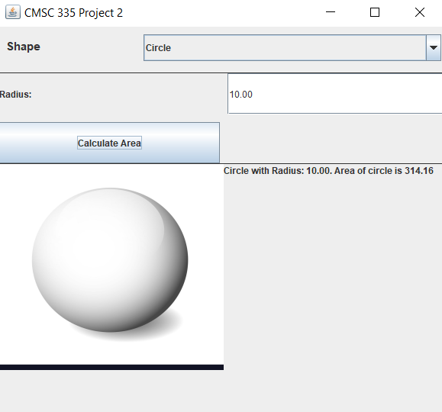
2. The second test involves creating a square. The user specifies a square with a length of 5. The appropriate area of the square is displayed subsequently, as the following screenshot indicates. 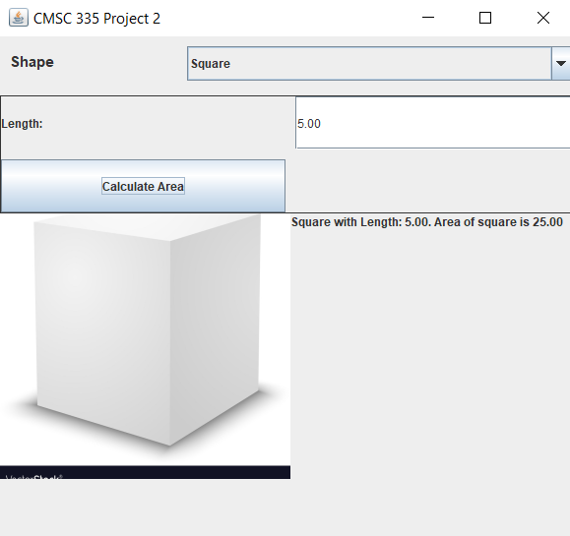
3. 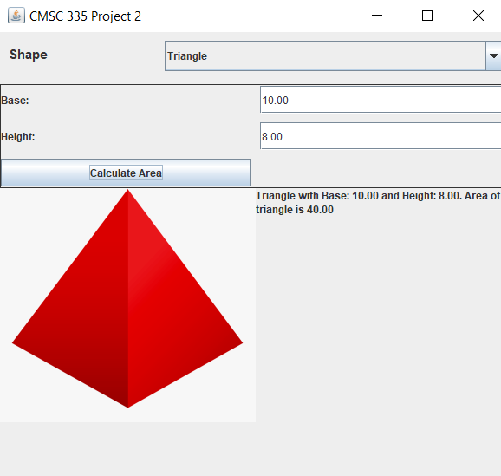The third test involves creating a triangle. The user creates a triangle with a base of 10 and a height of 8, and the program reports that the area of the triangle is 40, which is the correct and expected result.
4. The fourth test involves creating a rectangle. The user creates a rectangle with a width of 6 and a length of 7. The program correctly shows that the rectangle has an area of 42. 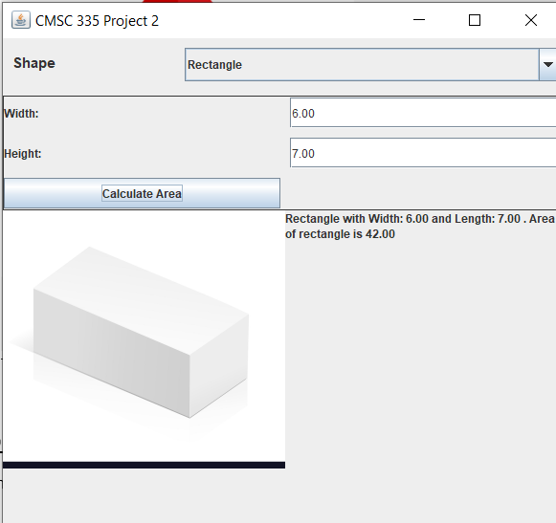
5. The fifth test involves creating a sphere with a radius of 9. The program correctly shows that the sphere has an area of 1017.88 and a volume of 3053.55. 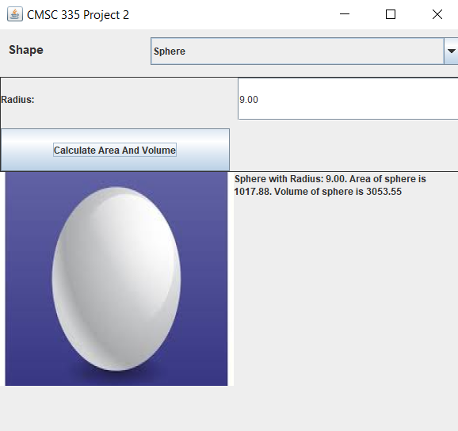
6. The sixth test involves creating a cube with edges of length 2. The program correctly indicates that the cube has an area of 24 and a volume of 8. 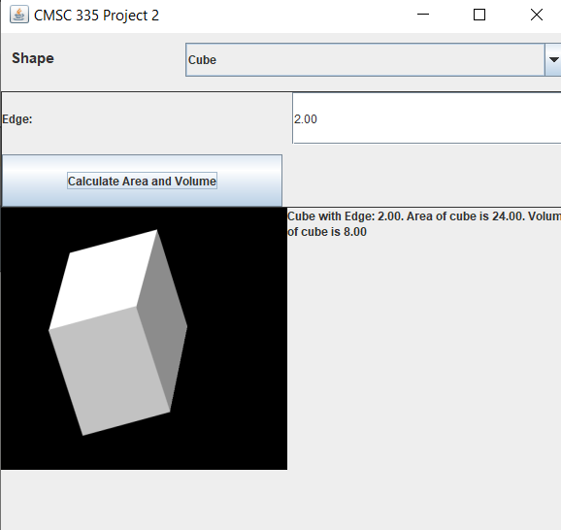
7. The seventh test involves creating a cone with a radius of 8 and a height of 6. The program displays the correct and expected resulting output that the cone has an area of 452.39 and a volume of 402.12. 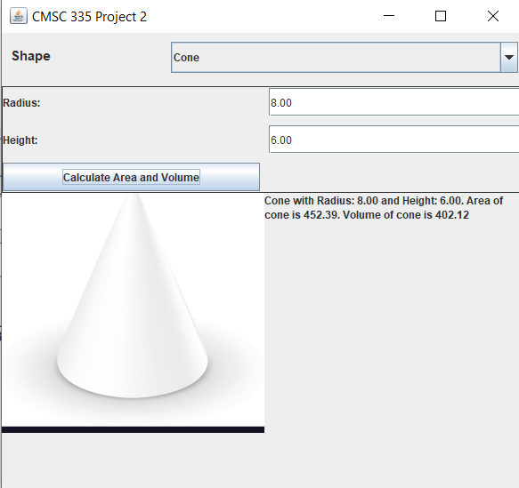
8. The eight test involves creating a cylinder with a radius of 2 and a height of 9. The program performs the correct mathematical computations to derive a cylinder with an area of 138.23 and a volume of 113.10. 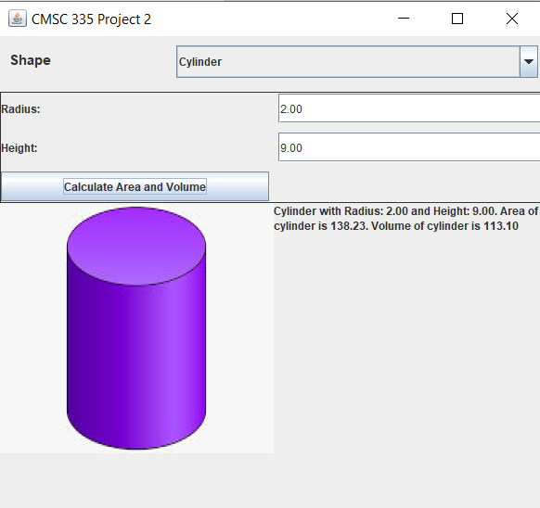
9. The ninth test case involves creating a torus with a minor radius of 3 and a major radius of 5. The program displays the correct and expected result that the torus has an area of 592.18 and a volume of 888.26. 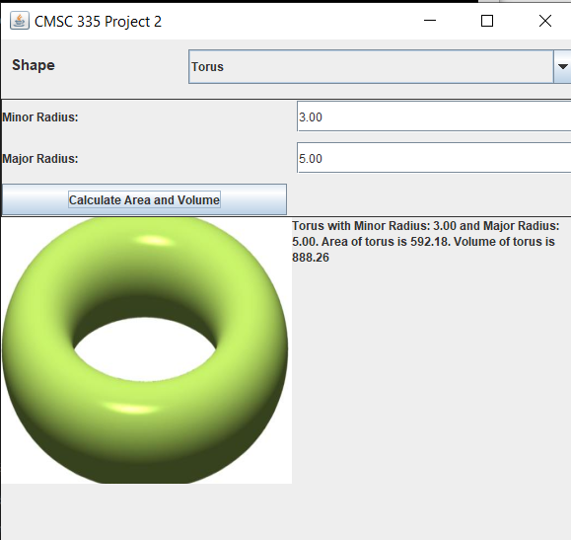

**Lessons Learned**

From this programming exercise, I learned more about the intricacies regarding Java GUI and how to use more of the features of each swing and AWT component. I also learned about how to use images in Java, particularly the ImageIcon class. I learned more about event listeners and event handlers. This project also helped reinforce my knowledge and for me to gain more experience working with Java classes, polymorphism, and inheritance. It was interesting using the previous blueprint provided by the classes I wrote in the preceding project to this one. This helped me learn the various stages involved in the development of a program. This project also gave me good experience writing my own methods, aside from writing my own classes and using Java Swing and AWT GUI.

**UML Diagram**

